Decouple an abstraction from its implementation so that the two can vary independently.
The Bridge Pattern is also known as Handle or Body.

Advantage of Bridge Pattern
- It enables the separation of implementation from the interface.
- It improves the extensibility.
- It allows the hiding of implementation details from the client.

Following participants constitute the bridge design pattern.
- Abstraction (abstract class)
It defined the abstract interface i.e. behavior part. It also maintains the Implementer reference.
- RefinedAbstraction (normal class)
It extends the interface defined by Abstraction.
- Implementer (interface)
It defines the interface for implementation classes. This interface does not need to correspond directly to abstraction interface and can be very different. Abstraction imp provides an implementation in terms of operations provided by Implementer interface.
- ConcreteImplementor (normal class)
It implements the Implementer interface.

When we need bridge design pattern
The Bridge pattern is an application of the old advice, “prefer composition over inheritance“.

Without bridge pattern
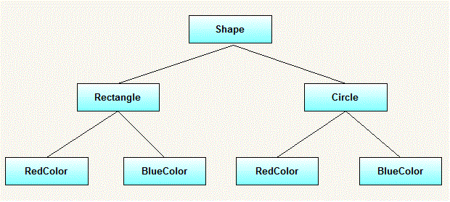

But above solution has a problem. If you want to change Rectangle class, then you may end up changing BlueRectangle and RedRectangle as well – and even if change is color specific then you may need to change Circle classes as well.
You can solve above problem by decoupling the Shape and Color interfaces in below manner.

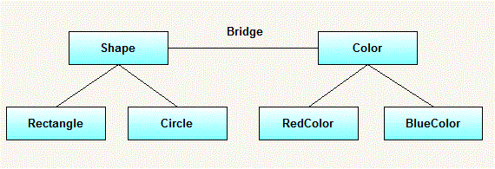

Now when you change any Shape, color would be unchanged. Similarily, vice-versa.

